**5×6 chess**

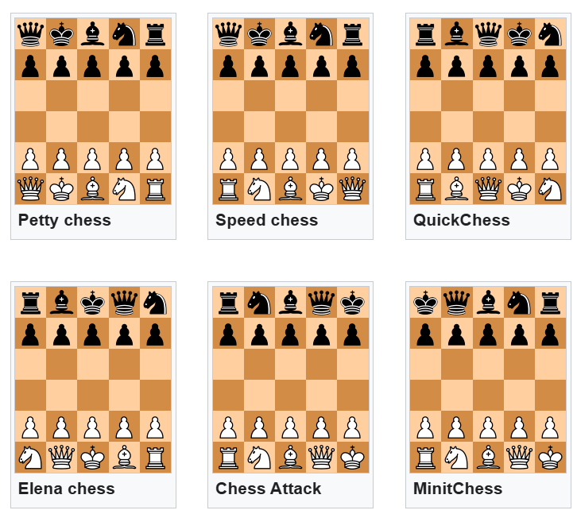

There are several chess variants on 5×6 board. The earliest published one is **Petty chess**, which was invented by B. Walker Watson in 1930.[[14]](https://en.wikipedia.org/wiki/Minichess#cite_note-14) **Speed chess** was invented by Mr. den Oude in 1988.[[15]](https://en.wikipedia.org/wiki/Minichess#cite_note-15) **Elena chess** was invented by Sergei Sirotkin in 1999.

**QuickChess** was invented by Joseph Miccio in 1991.[[16]](https://en.wikipedia.org/wiki/Minichess#cite_note-16) Pawn double-move and castling are not allowed in this variant, pawns can only promote to captured pieces. The game was sold by Amerigames International and received National Parenting Publications Award in 1993. Miccio obtained a US patent in 1993, which described three further chess variant on 5×6 board.[[17]](https://en.wikipedia.org/wiki/Minichess#cite_note-17) Besides two variants similar to *Speed chess* and *Elena Chess* (same position of white pieces, position of black pieces is symmetrical), the patent claimed one further variant, which have been named later *Chess Attack*. Miccio advocated these games as educational tools for children to learn chess rules. The smaller board and less pieces would reduce the complexity of the game and allow for more quicker games. The piece setup like in *Speed chess* was intended to teach short side castling and setup as in *Chess Attack* - long side castling.

[Laszlo Polgar](https://en.wikipedia.org/wiki/Laszlo_Polgar) published a book in 1994 *Minichess 777+1 Positions (Quickchess teaches chess quick)*,[[18]](https://en.wikipedia.org/wiki/Minichess#cite_note-18) completely devoted to chess on 5×6 board. Besides initial setup as in QuickChess, Polgar proposed to use any other possible setup of pieces, even asymmetrical ones. The book contained problems, combinations and games for 5×6 chess. Polgar recommended to use it as a first book to teach children to play chess.

[Magnus Carlsen](https://en.wikipedia.org/wiki/Magnus_Carlsen) promoting 5×6 chess variant *Chess Attack*

**Chess Attack**, which has the same setup as Gardner minichess (but played on a bigger board) is sold by Norway company *Yes Games AS* since 2008. In this variant, pawns can make double-moves and en-passant capture is allowed. The game was endorsed by [Magnus Carlsen](https://en.wikipedia.org/wiki/Magnus_Carlsen) and [Alexandra Kosteniuk](https://en.wikipedia.org/wiki/Alexandra_Kosteniuk).

[MinitChess](http://wiki.cs.pdx.edu/minichess), published in 2010 based on earlier 2007 and 2009 variants, is played on a Gardner board with the black pieces mirrored. In this variant there is no castling, no double pawn moves, pawn promotion only to queen, victory by king capture or when an opponent has no legal move (including moves which permit the king to be captured—these moves are legal), and draw after 40 moves by each side. In addition, the bishop is replaced by a *bad bishop* that has the additional option of moving to any adjacent empty square on its turn, allowing it to change color. This variant is intended to be easy to write computer programs to play and harder for expert human players of standard chess, while still retaining the essential character of the game: several computer tournaments have been held.